**Lab 13**

**Name :-** Aryan Dilipbhai Langhanoja

**Date :-** 04-09-2023

**Enrollment No :-** 92200133030

**CO1: To write, test, and debug simple Python programs**

**CO2: To implement Python programs with conditional, loops and functions**

**Task 1:- Plot a Line Grap Using Matplotlib**

**Python Code:**

x = np.arange(10)

y = 2*x + 4

plt.title("Line")

plt.xlabel("X Lable")

plt.ylabel("Y Lable")

plt.plot(x,y)

plt.show()

**Output:**

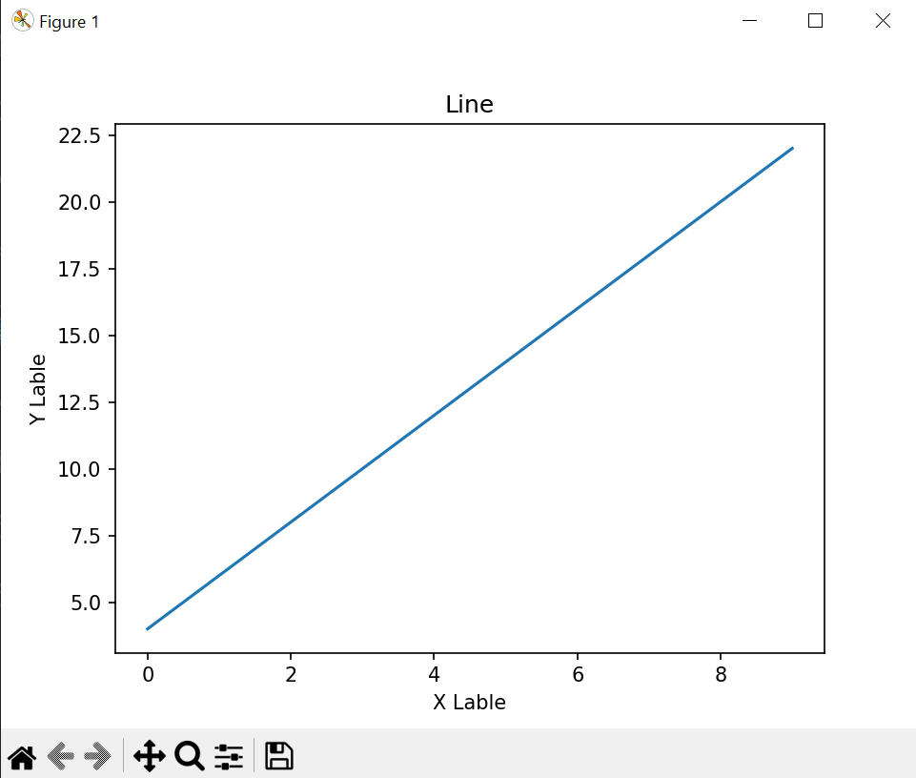

**Task 2:- Using Subplot in Matplotlib**

**Python Code:**

plt.subplot(1,2,1)

plt.plot([1,2,3], [3,2,1])

plt.title("First Plot")

plt.subplot(1,2,2)

plt.plot([2,4,6], [1,2,3],"r")

plt.title("Second Part")

plt.show()

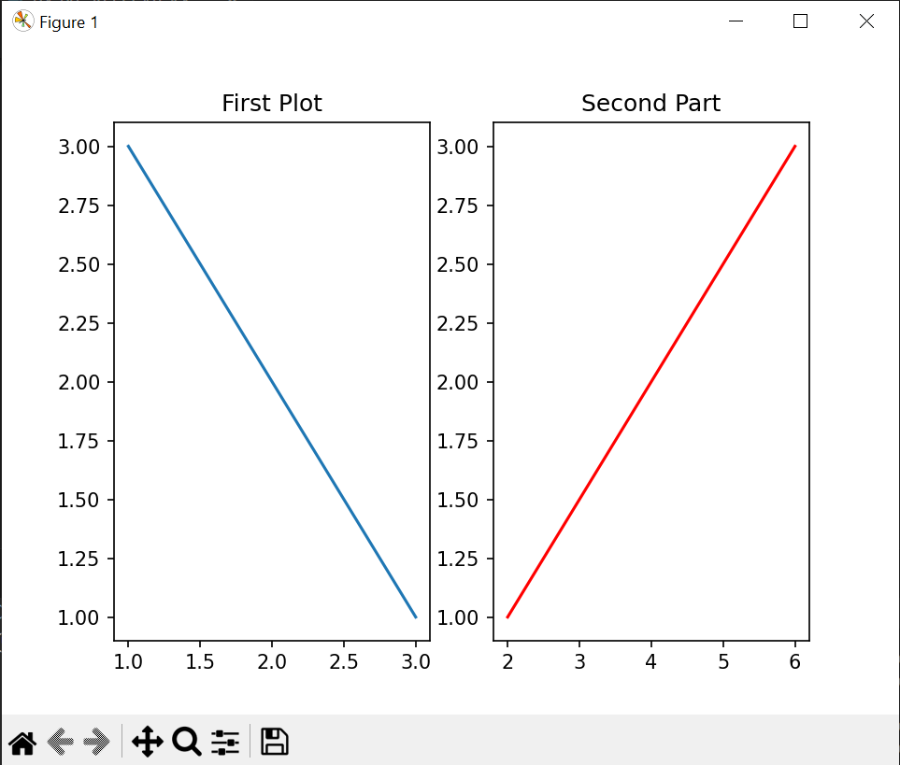**Output:**

**Task 3:- Plot Bar Plot Using Matplotlib**

**Python Code:**

plot = plt.figure()

chars = ['A' , 'B' , 'C']

values = [7,9,3]

plt.bar(chars,values)

plt.show()

**Output:**

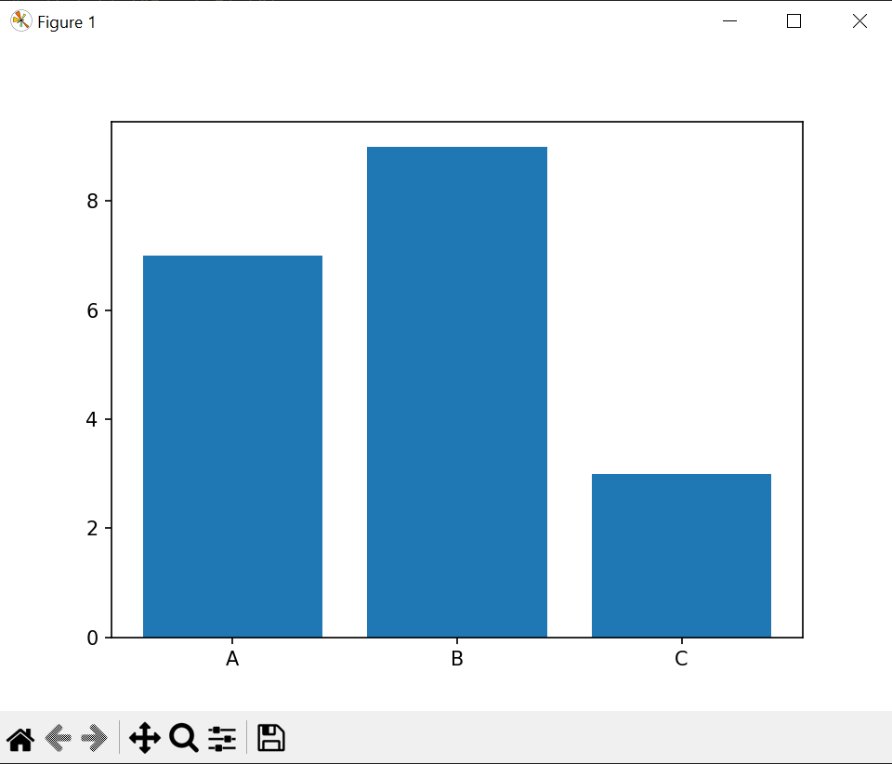

**Task 4:-** **Plot Histogram Using Matplotlib**

**Python Code:**

x = [20,40,60,90,50,20,70,20,20,10,90]

nums = 4

plt.hist(x, nums)

plt.show()

**Output:**

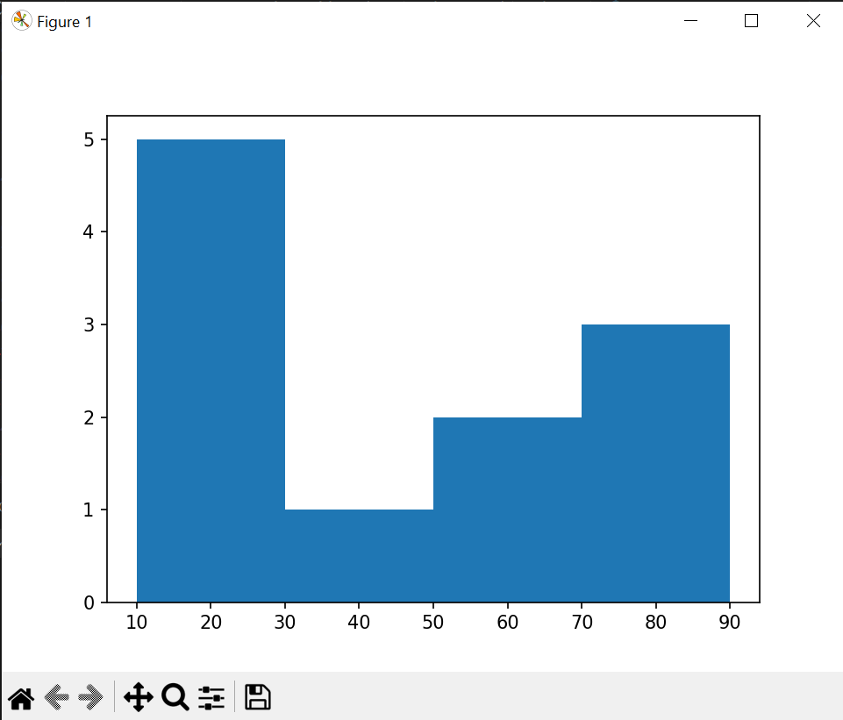

**Task 4:-** **Plot Histogram Using Matplotlib**

**Python Code:**

list1 = [44,56,73,89,45,31]

list2 = [10,20,30,50,40,30]

fig = plt.figure()

plt.scatter(list1,list2, color = "g")

plt.show()

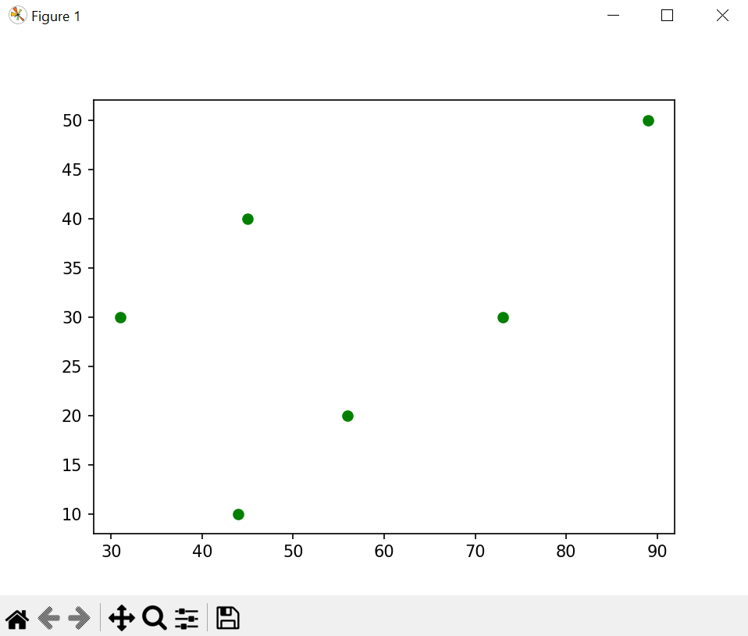**Output:**

**Task 5:-** **Plot Histogram Using Matplotlib**

**Python Code:**

wave = np.arange(0,2*np.pi,0.2)

g_sin = np.sin(wave)

g_cos = np.cos(wave)

plt.subplot(2,1,1)

plt.title("Sine Wave")

plt.plot(wave,g_sin, color = "Green")

plt.subplot(2,1,2)

plt.title("Cos Wave")

plt.plot(wave,g_cos,color = "red",linestyle = ":")

plt.show()

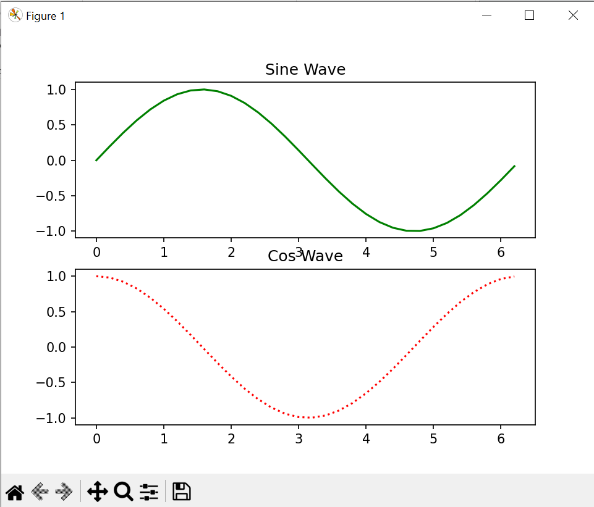**Output:**